

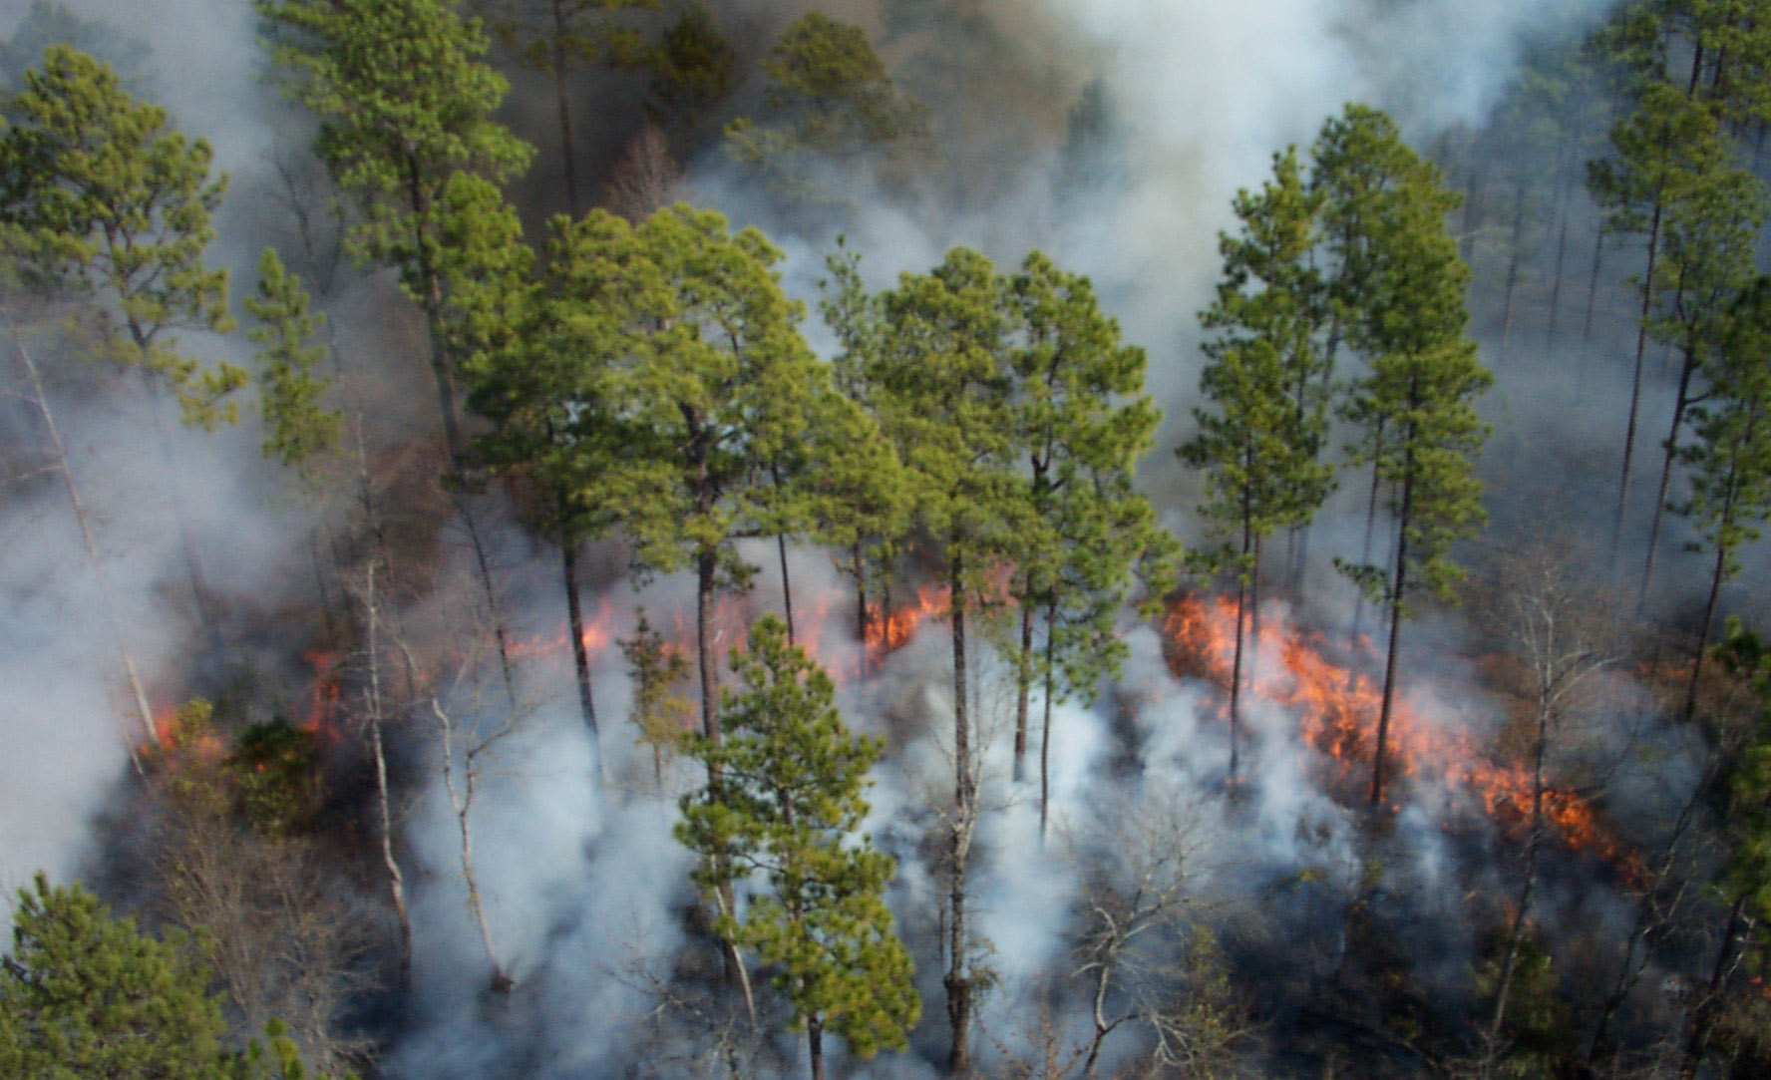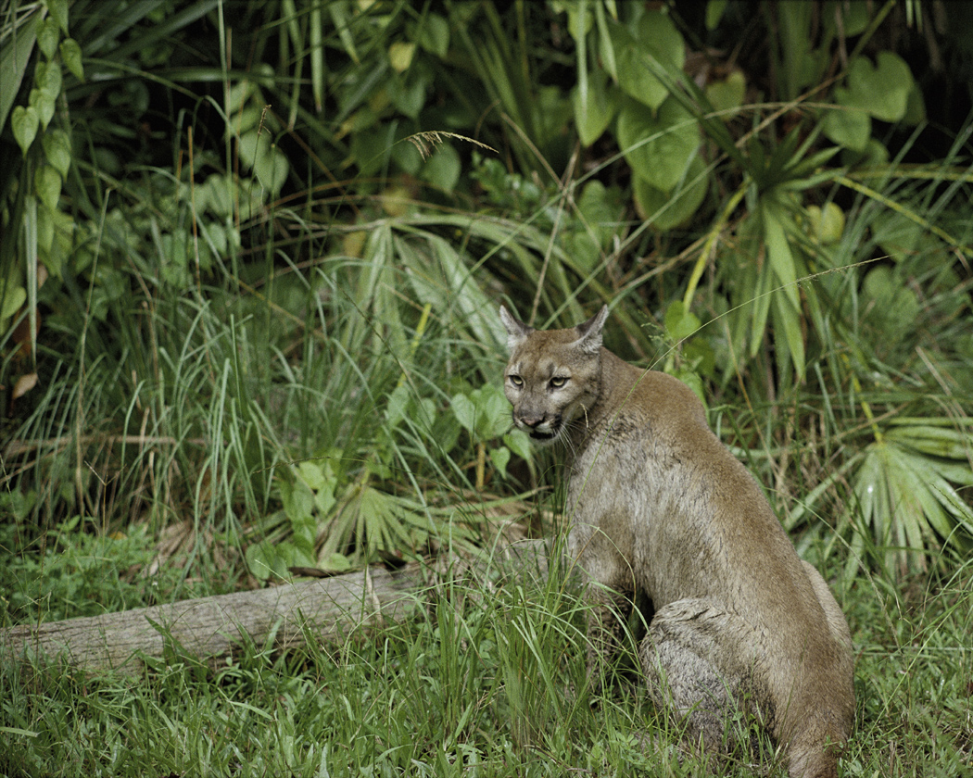

ERAtools

September 20, 2010
Version 2.8

URS Corporation
1625 Summit Lake Drive, Suite 200
Tallahassee, Florida 32317

Table of Contents

1. Introduction 1-1
2. Using ERAtools 2-1
2.1 ERAtools Toolbar 2-1
2.2 ERAtools Menu 2-1
2.3 ERAtools Settings 2-1
2.3.1 Output Formats Folder 2-2
2.3.2 Saved Shapes Geodatabase 2-2
2.3.3 Author Name 2-2
2.3.4 Warn Before Replacing Output File 2-3
2.4 Drawing Analysis Features on the Map 2-3
2.5 Using the Select Features Button 2-4
2.6 Using Previously Saved Shapes 2-4
2.7 Main ERAtools Screen 2-5
2.8 Running the Report 2-7
3. Understanding Report Content 3-1
3.1 Analysis Types 3-1
3.1.1 Pinpoint Analysis 3-1
3.1.2 Generic Resource Analysis 3-1
3.1.3 Weighted Average 3-1
3.1.4 Feature Comparison 3-4
3.1.5 Distance 3-5
3.1.6 Distance and Direction 3-8
3.1.7 Comparison Resource 3-9
3.2 Related Tabular Data 3-10
3.2.1 In-Line Related Tables 3-10
3.2.2 Nested Related Tables 3-10
3.3 Data Summarization 3-10

Table of Figures
Figure 2-1: ERAtools Toolbar and Menu 2-1
Figure 2-2: ERAtools Settings Dialog 2-2
Figure 2-3: Selected Features Dialog 2-4
Figure 2-4: Saved Shapes Dialog 2-5
Figure 2-5: Main ERAtools Screen 2-6
Figure 2-6: Main ERAtools Screen with Name Field Displayed 2-7
Figure 2-7: Example Report Output 2-8
Figure 2-8: Analysis Feature and Buffer Displayed on Map 2-9
Figure 3-3: Generic Resource Analysis 3-1
Figure 3-4: Weighted Average Analysis 3-3
Figure 3-5: Feature Comparison Analysis (Point or Linear Analysis Features) 3-4
Figure 3-6: Feature Comparison Analysis (Polygon Analysis Features) 3-5
Figure 3-7: Distance Analysis: Point-to-Point 3-5
Figure 3-8: Distance Analysis: Point to Line 3-6
Figure 3-9: Distance Analysis: Point-to-Polygon 3-6
Figure 3-10: Distance Analysis: Line to Point 3-7
Figure 3-11: Distance Analysis: Line to Line 3-7
Figure 3-12: Distance Analysis: Line to Polygon 3-7
Figure 3-13: Distance Analysis: Polygon to Point 3-8
Figure 3-14: Comparison Resource Analysis: Point Features 3-9
Figure 3-15: Comparison Resource Analysis: Linear Features 3-9
Figure 3-16: Comparison Resource Analysis: Polygon Features 3-10

Introduction
The Florida Fish and Wildlife Conservation Commission (FWC) has contracted with URS Corporation Southern to design and develop a system to support the management of data associated with an objective-based vegetation management (OBVM) approach to resource management on FWC lands. This data management system will contain information on vegetation monitoring data, provide statistical summarization of these data, and compare this information with defined management objectives, in order to provide FWC area managers with data to support management decisions, to assess the conditions of plant communities, and to assess the effectiveness of land management activities on the plant community structure.
A significant portion of the end-user functionality of this system will be the presentation of summarized data via the ERAtools ArcMap extension. Development was started by the Florida Department of Environmental Protection and completed by URS under an extension to the original OBVM Data Management and Interpretation Tools contract.
The Florida Department of Health funded the development of several new features of ERAtools and the ERAtools Administrator application, including a modification of the weighted average analysis and the addition of the Direction and Distance analysis, and options to the ERAtools interface to suppress warning messages.
The U.S. Fish and Wildlife Service funded a modification to this application to change how “saved” shapes are stored. These are now stored in the WGS 1984 geographic coordinate system, allowing for analysis features outside of the State of Florida to be saved. (Versions 2.7 and earlier stored data in the Florida Albers projection.)
This document provides an overview of the functionality of ERAtools. Refer to the ERAtools Administrator documentation for more information on defining ERAtools reports.
This release of ERAtools has been written for the ArcMap 9.2 or 9.3 platforms. It is not compatible with ArcMap 8 or ArcView 3, and has not been tested on ArcMap 10. The Microsoft .Net framework version 2.0 is required for this extension to run.

Using ERAtools
The application is presented as a toolbar that appears in the ArcMap user interface.
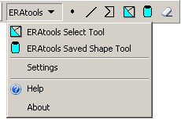
Figure 2-1: ERAtools Toolbar and Menu
Note: If the toolbar is not visible, select ERAtools from the View→Toolbars menu.

ERAtools Toolbar

The toolbar has five buttons:

  | Point Tool: used to define a point as the analysis feature
  | Polygon Tool: used to define an area to use as the analysis feature
  | Line Tool: used to define a line or polyline to use as the analysis feature
  | Selected Features button: used to run the report using the selected feature(s) on the map
 | Clear Analysis Features Button: Clears all analysis features on the map
 | Saved Shapes Button. Opens the Saved Shapes dialog, allowing you to run ERAtools reports using features saved during previous runs.

ERAtools Menu
The ERAtools menu repeats the options for running reports with selected features or saved shapes, and in addition contains options for changing system settings, accessing help (this document), and an About dialog which gives you information about the version of ERAtools installed on your system.

ERAtools Settings
The Settings dialog, shown in Figure 2-2, is accessed from the ERAtools menu, and gives you options to change certain settings, described below.
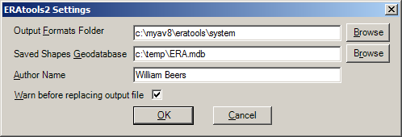
Figure 2-2: ERAtools Settings Dialog

Output Formats Folder
The output formats displayed in the Select Output Format dropdown list on the main ERAtools form are read from this folder. By default this is the ERAtools System Folder chosen during setup, but can be changed to any valid path containing properly formatted XSLT documents that define the output formats.

Saved Shapes Geodatabase
Enter or browse to the path to a personal geodatabase file that will be used to store saved shapes (the points, lines or polygons you digitize when running reports). You may enter a path to a file that does not exist, and ERAtools will create the file. If the file already exists, new feature classes named Point, Line and Polygon will be added to the geodatabase. If feature classes with these names already exist in the geodatabase and the structure of the feature classes is not consistent with the ERAtools requirements (described in Table 2-1), an error will be generated.
Field Name | Type | Size | Description
OBJECTID | AutoNumber | Long Integer | System-maintained unique identifier
SHAPE | OLE Object | N/A | Stores the shape for the feature
ShapeName | Text | 255 | Stores the name of the saved shape, as provided by the user
DateCreated | Date | N/A | Stores the date/time the shape was created.
Table 2-1: Saved Shapes Layer Requirements
The simplest way to manage this is to let ERAtools automatically create the geodatabase and layers. The layers will be created using the WGS 1984 geographic coordinate system. This can be modified to use any valid coordinate system, and ERAtools will project analysis features if necessary.

Author Name
The Author Name setting controls the text that will appear on reports generated by ERAtools. By default, this will be set to your network logon ID. You can change this to any value, but note that if you enter nothing in this field, your network logon ID will be used as the default.

Warn Before Replacing Output File
Check this box to be warned when the output file being created by ERAtools already exists.

Drawing Analysis Features on the Map
Before you use ERAtools to define analysis features, be sure that your map has a defined coordinate system set. Layers loaded in the map, and the layers being analyzed, should all have defined coordinate systems for ERAtools to function properly.
The point, polygon and line tools require you to interact with a map to draw a point, line or polygon on the screen.
To draw a point analysis feature:
- Select the Point tool
- Click once anywhere on the map
- Click cancel on the ERAtools screen when it appears.
To use the Line tool to draw a line:
- Select the Line tool
- Click once anywhere on the map to start a line.
- Click again to add vertices to the line.
- Double-click to finish the line.
- Click cancel on the ERAtools screen when it appears.
To use the Polygon tool to draw a polygon:
- Select the Polygon tool
- Click once anywhere on the map to start a polygon.
- Click again to add vertices to the polygon. You must add at least one vertex between the start and end of the polygon.
- Double-click to finish the polygon.
- Click cancel on the ERAtools screen when it appears.

Using the Select Features Button
The Select Features button is enabled when you have at least one feature selected on your map. Use the standard select features tool, or select features by location or attribute option to select one or more features in layers loaded in your map.
If there is more than one feature selected, you will be prompted to select which layer the features are found in (if there is more than one layer with selected features), and whether the selected features should be joined into a single shape or if you want a separate report to be run for each individual feature.
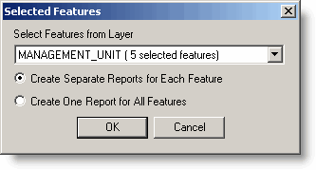
Figure 2-3: Selected Features Dialog
If only a single feature is selected, this screen is not displayed.

Using Previously Saved Shapes
You can re-run an analysis using analysis features saved on previous runs of the application. Select the ERAtools Saved Shape Tool from the ERAtools menu or toolbar, and the Saved Shapes dialog will be displayed (Figure 2-4).
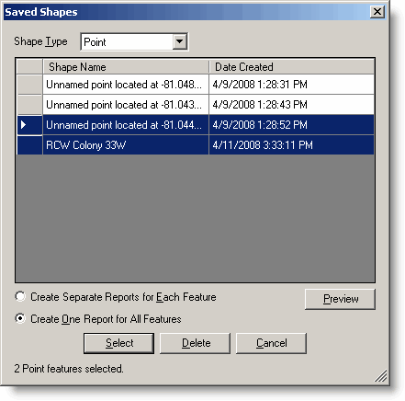
Figure 2-4: Saved Shapes Dialog
Select the shape type from the Shape Type drop-down list, and all saved shapes of the selected type will be displayed in the table. Select one shape by clicking on a row in the table. Multiple shapes can be selected by holding down the shift key to select a range, or the control key to select or deselect individual rows in the table. To preview the selected shape on the map, click the Preview button. As with the Selected Features tool, you can choose to run a single report for all selected features, unioned into a single multi-part shape, or individual reports for each selected feature. You can maintain your set of saved shapes using this dialog as well. Simply select shapes you wish to delete and click the Delete button. To add new features to the database, select the Save Shape checkbox on the main ERAtools screen (described in Section 2.7).

Main ERAtools Screen
After you have drawn a point, line or polygon, or selected features and clicked the Select Features button, the main ERAtools screen will appear (Figure 2-5).
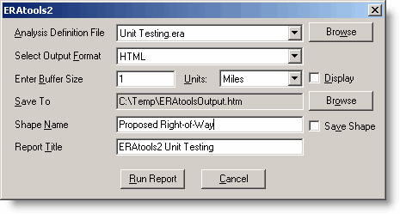
Figure 2-5: Main ERAtools Screen
This screen has inputs for:
- Analysis Definition File: an XML format file (usually with a file extension .era, but .xml may also work, as long as the content of the XML file is compatible with ERAtools) created by the ERAtools administrator, which define the layers and tables to be analyzed, and how the data are to be summarized and presented. Typically these are stored together a single folder, and are listed in the Analysis Definition File drop-down list. If the analysis definition file is not found in the list, you can use the Browse button to browse for it. The drop-down list will automatically be filled with all ERAtools analysis definition files found in the same folder as the selected file.
- Output Format: defined by a custom XML transform file (file extension .xsl), converts the report output into a format for display in a Web browser or other appropriate program. Upon installation, the following output formats are provided:
- HTML: suitable for display over the Web or on your desktop via Internet Explorer
- Word: Microsoft Word document
- Excel: Microsoft Excel spreadsheet
The transform files specify both the type of file to be created as well as the colors and layout. Additional transform files can be created and placed in the ERAtools system folder (c:\myav8\eratools2\system) to define additional output formats.
- Buffer Size and Units: many analysis types support analysis of features as well as associated buffers. To run an analysis using a buffer, enter a positive number in the Enter Buffer field, and select the appropriate units. To skip running a buffer, leave this field blank or enter a 0. The buffer distance allows you to buffer the drawn or selected features to create a larger analysis area. For example, if you digitize a line that represents a road corridor, you would enter a suitable width to represent the area impacted by the road. The Display checkbox specifies whether you want the buffer to be drawn on the map after the report is run.
- Save To: Use the associated browse button to specify the output report file to be created by ERAtools.
- Depending on whether you are running the report with multiple selected features or single digitized features, one of the following shape naming options will be displayed.
- Shape Name: Enter a name to identify the feature you are using for analysis purposes. If left blank, a default name will be generated by ERAtools based on the geometry of the shape. This option is shown when you are running a report using user-digitized features (using the Point, Line or Polygon tools), or if you are running a report using the Selected Features tool for a single selected feature, or running a single report for multiple selected features.
- Name Field: If you are running a report using the Selected Features tool with multiple features selected, and you choose the “Create Separate Reports for Each Feature” option, a drop-down list will appear in place of the Shape Name text box. The drop-down list will contain the fields of the layer with the selected features (Figure 2-6). Select a field name to use for naming individual features. For each selected feature, the value stored in the indicated field will be used as the shape name.
- Report Title: Enter a title to use for the report. This is optional, and may be filled in already, if the creator of the analysis definition file has chosen to enter a default title.
- Save Shape: Check this checkbox to save the shape to the ERAtools2 geodatabase. This will allow you to re-run the report using the saved shapes dialog (Section 2.6).

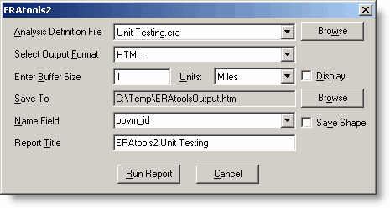
Figure 2-6: Main ERAtools Screen with Name Field Displayed

Running the Report
Once you have entered the required options on the main ERAtools form, click the Run Report button to see the results of the analysis. The content and format of the output are dependent on how the administrator has defined the reports.
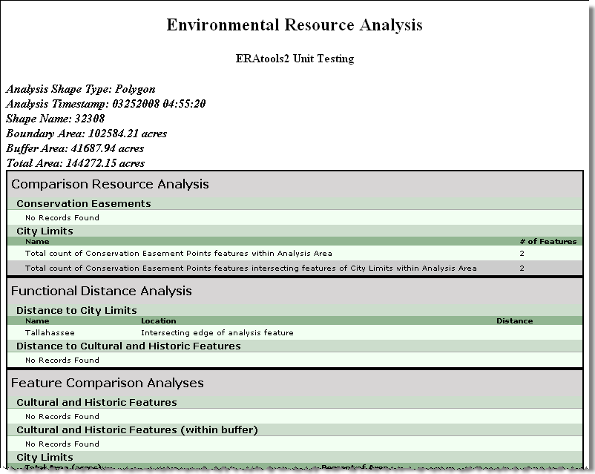
Figure 2-7: Example Report Output
The feature is shown on the map (Figure 2-8). If a buffer size greater than zero was entered and the Display checkbox was checked, then the buffer will also be displayed.
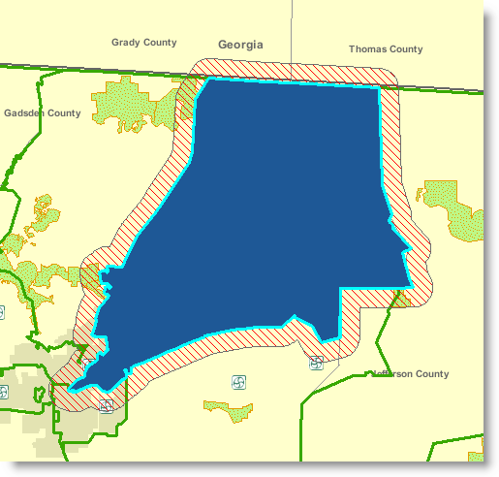
Figure 2-8: Analysis Feature and Buffer Displayed on Map

Understanding Report Content
The content of a report is based on an analysis definition file, which is created by using the ERAtools Administrator application. Documentation for that application provides more information on analysis definition files, but for giving you a better understanding of the output from ERAtools, an overview of ERAtools concepts are provided in this section.

Analysis Types
Several types of Analyses are available, as described below. In the descriptions, the following terms apply:
Resource Feature: The data layer being analyzed, as specified by the Layer ID property of an analysis.
Analysis Feature: The geographic feature digitized or selected by the ERAtools user and used as the basis for the analysis.
Buffer: Also known as the analysis area—represents the polygon surrounding the analysis feature, the size of which is based on the buffer distance selected by the ERAtools user.

Pinpoint Analysis
The Pinpoint analysis lists specified attributes of all resource features that intersect the analysis feature. The buffer is not used.

Generic Resource Analysis
The Generic Resource analysis lists specified attributes of resource features that intersect the analysis feature. If a buffer is used during the analysis run, attributes for resource features intersecting the buffer will be listed separately.
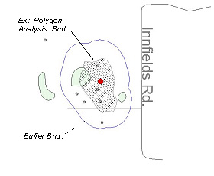
Figure 3-9: Generic Resource Analysis

Weighted Average
The Weighted Average analysis weights specified numeric attributes of the intersecting resource features based on the proportion of the intersecting area (the overlap of the analysis feature or buffer area and the resource feature) within the entire analysis area. This analysis type is primarily designed for analysis of polygon resource features within a polygon analysis feature, or buffered line or polygon analysis feature. Depending on the feature type (point, line or polygon) of the resource feature, the analysis behaves differently:
- Point or Linear Resource Features: reports the sum of the specified numeric attributes of resource features within the analysis area.
- Polygon Resource Features: reports the sum of specified numeric attributes values of resource features within the analysis area, and weights the values for each resource feature proportionally to the overall size of either the analysis feature or resource feature (both options are provided).
The proportional-to-analysis-feature-size option is useful for datasets where the data being analyzed represents some kind of index that is independent of the overall size of the resource feature. Examples include the population density in a given area, or the land use intensity index for a given area. This method weights the individual values by the proportion of the analysis feature comprised of the intersecting resource feature. The formula for this method is shown below:
Σ (
Overlap Area * Value )
Total Overlap Area
The proportional-to-resource feature-size option is useful for datasets where the data being analyzed represents a total count of things contained by the resource feature, thus making the overall size of the resource feature relevant to the calculation. Examples include the total population of a given area, or a count of wildlife observations within a wildlife management area. Although it’s referred to as a weighted average, in this case it may be more accurate to think of the analysis as a weighted sum. It is included as an option within the weighted average analysis so that both methods can be employed on a single layer being analyzed. The formula for this method is shown below:
Σ (
* Value )
Overlap Area
Resource Area

Both options take into account no-data portions of the analysis feature. The portions of the analysis feature that do not intersects any resource features, or which intersect resource features with null values for the field being analyzed, are excluded from the analysis.
The example shown below in Figure 3-10 shows several census tracts, labeled by tract ID. The data for the tracts intersecting the analysis feature is shown in the table below the graphic.
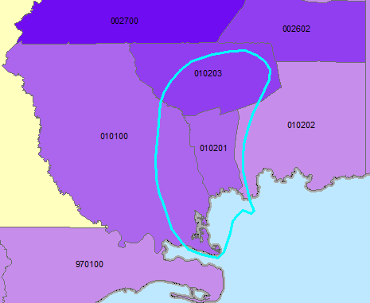
Figure 3-10: Weighted Average Analysis

Tract | Resource Feature Area | Overlap Area | Population
Tract | Resource Feature Area | Overlap Area | Total | Density
010100 | 314.26 | 61.01 | 5308 | 16.9
010201 | 40.36 | 40.36 | 5642 | 139.7
010202 | 160.75 | 10.00 | 4253 | 26.5
010203 | 102.03 | 59.45 | 7660 | 75.1
No Data |  | 23.38 | N/D | N/D
Total/Avg | 194.20 | 194.20 | 22863 | 64.55

A weighted average analysis performed on this data, using the cyan-highlighted analysis feature, will result in a weighted average population density (using the indexed, proportional-to-analysis-feature option) of 66.7 persons per square mile, calculated are as follows:
(61.01 * 16.9) + (40.36 * 139.7) + (10.00 * 26.5) + (59.45 * 75.1)
(61.01 + 40.36 + 10 + 59.45)
= 66.7
This is slightly different from the non-weighted average of the density field (64.55), because it takes into account the relative proportions of the census tracts within the analysis area.
A weighted average analysis of the total population (using the indexed, proportional-to-resource feature option) is as follows:
10
160.75

61.06
314.26

* 5308 +

40.36
40.366

* 5642 +

59.45
102.03

* 4253 +

* 7660 = 11,400

The result of 11,400 persons is considerably smaller than a simple sum of the total population, as it takes into account that only portions of some of the intersecting census tracts are within the analysis area.

Feature Comparison
The Feature Comparison analysis summarizes the unique values found in features in the resource layer that intersect the analysis area, and reports the amount of those features as follows, based on the analysis and resource layer geometry types:
- For point and linear analysis features, this analysis reports attributes from the resource and:
  - For point resources, a count of features within the analysis buffer area
  - For linear resources, the total linear feet within the analysis buffer area
  - For polygon resources, the total acres within the analysis buffer area.
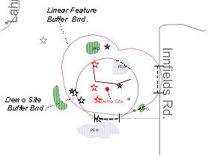
Figure 3-11: Feature Comparison Analysis (Point or Linear Analysis Features)
- For polygon analysis features, this analysis reports attributes from the resource and:
  - For point resources, a count of features within the analysis area and a count of features within the buffer area
  - For linear resources, the total linear feet within the analysis area and the total linear feet within the buffer area
  - For polygon resources, the total acres within the analysis area and the total acres within the buffer area
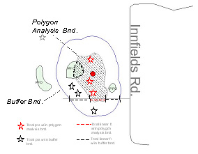
Figure 3-12: Feature Comparison Analysis (Polygon Analysis Features)

Distance
The Distance analysis lists resource features that intersect the user-specified analysis feature and buffer, and reports the distance of the resource feature from the analysis feature. This analysis will not run correctly if the user does not enter a buffer distance greater than zero. Based on the geometry types of the analysis feature and resource features, this analysis reports as follows:
- Point Analysis Features
  - Point Resource Feature: from the point analysis feature, reports the distance to point features within the analysis area.
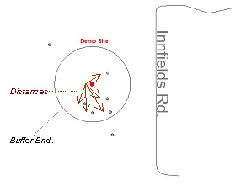
Figure 3-13: Distance Analysis: Point-to-Point
  - Linear Resource Features: from the point analysis feature, reports the distance to the closest point of linear resources features within the analysis area.
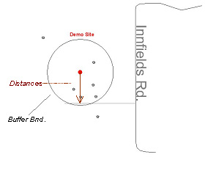
Figure 3-14: Distance Analysis: Point to Line
  - Polygon Resource Features: from the point analysis feature, reports the distance to the closest point on the perimeter of polygon resource features within the analysis area.
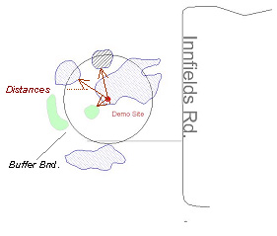
Figure 3-15: Distance Analysis: Point-to-Polygon
- Linear Analysis Features
  - Point Resource Features: from the closest point on the linear analysis feature, reports the distance to point resource features within the analysis area.
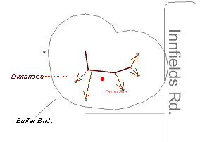
Figure 3-16: Distance Analysis: Line to Point
  - Line Resource Features: from the closest point on the line analysis feature, reports the distance to the closest point on line resource features within the analysis area.
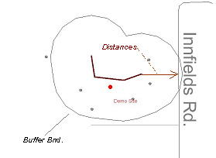
Figure 3-17: Distance Analysis: Line to Line
  - Polygon Resource Features: from the closest point on the line analysis feature, reports the distance to the closest point on the perimeter of polygon resource features within the analysis area.
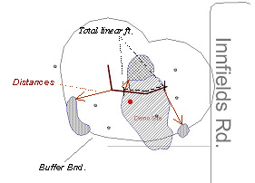
Figure 3-18: Distance Analysis: Line to Polygon
- Polygon Analysis Features
  - Point Resource Features Intersecting the Analysis Feature: reports the distance from point features within the polygon analysis feature to the closest point on the perimeter of the polygon analysis feature.
  - Point Resource Features Intersecting the Buffer Area: reports the distance from point features outside the polygon analysis feature to the closest point on the perimeter of the polygon analysis feature.

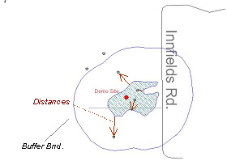
Figure 3-19: Distance Analysis: Polygon to Point
  - Linear Resource Features Intersecting the Analysis Feature: reports the closest distance from a point on line features within the polygon analysis feature to the closest point on the perimeter of the polygon analysis feature.
  - Linear Resource Features Intersecting the Buffer Area: reports the closest distance from a point on line features outside the polygon analysis feature to the closest point on the perimeter of the polygon analysis feature.
  - Polygon Resource Features Intersecting the Analysis Feature: if resource feature is entirely within the analysis feature, and their edges do not intersect, reports the shortest distance from a point on the edge of the resource feature to a point on the edge of the analysis feature.
  - Polygon Resource Features Intersecting the Buffer Area: reports the closest distance from a point on polygon features outside the polygon analysis feature to the closest point on the perimeter of the polygon analysis feature.
In all cases, if a resource feature intersects (overlaps) the edge of an analysis feature (such as when a linear resource intersects a linear analysis feature, or when a polygon resource intersects the edge of a polygon analysis feature), the analysis reports “Intersects analysis feature”

Distance and Direction
The Distance and Direction analysis performs the same distance analysis as described above, but also includes a field that gives the direction from the analysis feature to the resource feature. The direction given is between the two closest points between the analysis feature and resource feature.

Comparison Resource
The Comparison Resource analysis summarizes a pair of analysis layers, a “parent” layer (the layer specified in the analysis setup screen), and a “child” layer (set up as a sub-table, as if it were a one-to-many relationship). The parent layer must contain polygon features. The child layer can contain point, line, or polygon features. See Section Error: Reference source not found for information on how to set up this analysis. Depending on the child layer feature type, this analysis reports as follows:
- Point analysis features: Lists the count of features from the child analysis layer within the analysis area, categorized by whether they intersect polygon features of the parent layer.
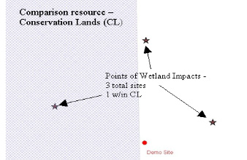
Figure 3-20: Comparison Resource Analysis: Point Features
- Liner analysis features: Lists the total length of linear features from the child analysis layer within the analysis area, categorized by whether they intersect polygon features of the parent layer.

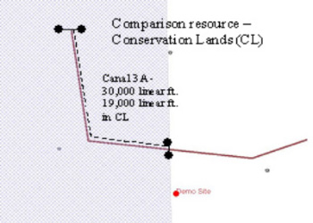
Figure 3-21: Comparison Resource Analysis: Linear Features
- Polygon analysis features: Lists the total area of polygon features from the child analysis layer within the analysis area, categorized by whether they intersect polygon features of the parent layer.
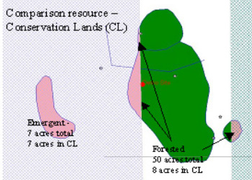
Figure 3-22: Comparison Resource Analysis: Polygon Features

Related Tabular Data
Certain analysis types (those that return individual records, including pinpoint, generic and distance) can list data associated by spatial relationship or by attributes (primary/foreign key columns that allow records to be related), either in-line with the data returned by the analysis, or as nested sub-tables. For example, if a basic pinpoint analysis returned a list of sample points, the multiple records associated with a sample point could be displayed in a nested table. The ERAtools Administrator document provides more information on how to set up these related table relationships.

In-Line Related Tables
In-Line Related tables are intended for relationships where a selected feature or features relate to a single record in the related table, such as when looking up a value in a lookup table to provide a description for a code used in the layer being analyzed. These data are displayed in the report alongside the records returned from the layer being analyzed.

Nested Related Tables
Nested related tables are intended for relationships where a selected feature relates to one or more records in the related table. For example, if the layer being analyzed represented management units, the related table could list the multiple management activities associated with that management unit. These records are shown in a separate table nested underneath each row returned from the layer being analyzed.

Data Summarization
Data can also be summarized, grouping by distinct values returned from a field and totaling, averaging or performing other summary functions on numeric fields.

